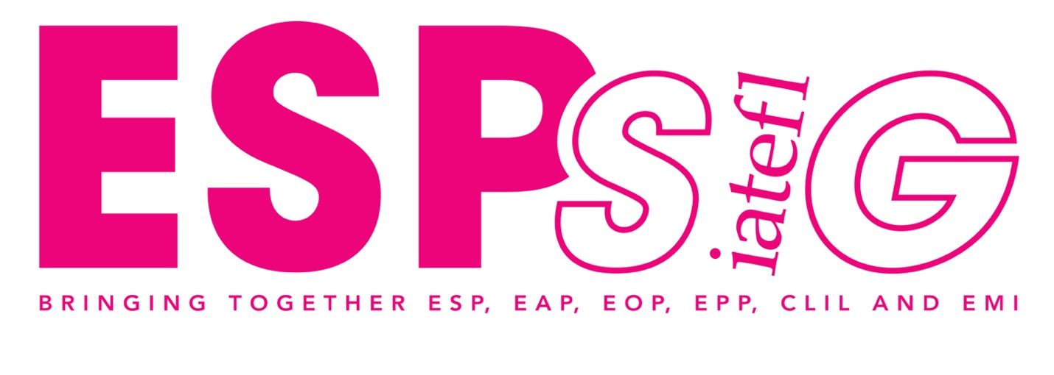

ESPSIG Pre-Conference Event 2025

21st Century Skills in the ESP Classroom

7 April 2025, 09:30 – 17:00
https://espsig.iatefl.org/

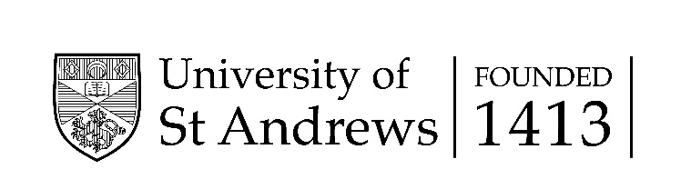 | 

SCHEDULE
Time | Activity | Presenter(s)
10.00 - 10.05 | Welcome
10.05 - 10.35 | Roving Reporter scholarship winner | Serge Petrenko
10.35 - 10.55 | Materials Development talks | Tania Pattison  George Kokolas
11.00 - 11.10 | Technology and AI talk | Ioana Cretu
11.10 - 11.30 | Coffee break
11.30 - 12.00 | ESP and EMI talks | Nadiia Grytsyk  Gerlinde Koppitsch  Alla Fridrikh
12.00- 13.00 | Roundtable discussions on Materials Development, Technology and AI & ESP and EMI | All MD, AI & EMI presenters
13.00 - 14.00 | Lunch
14.00 - 15.15 | Materials Development,Technology and AI & ESP and EMI Workshops | Tania Pattison (Materials Development)  Ioana Cretu (AI)  Nadiia Grytsyk (EMI)  Gerlinde Koppitsch (EMI)  Alla Fridrikh (EMI)
15.15 - 15.30 | Coffee break
15.30 - 16.35 | Lightening Talks
16.35 - 17.00 | Quiz, wrap-up

ABSTRACTS
ROVING REPORTER SCHOLARSHIP WINNER
Serge Petrenko, National University of Kyiv (Ukraine) serge.v.petrenko@gmail.com
Talk: Holistic approach to teaching and learning in Ukraine
ESP is an obligatory course for all undergraduate students at Ukrainian higher educational institutions, the content of which depends mainly on analyzing the needs of the target group of learners, whose social demand is reflected in the ESP course aims. The understanding and interpretation of ESP by university teachers and the approaches they choose for teaching and learning ESP also influence the content of an ESP course.
According to the societal demand of Ukraine, the ESP National Curriculum for Universities (2005, pp. 33-34) set six aims for university ESP courses: practical (develop students’ general and professionally oriented communicative language skills in English), educational (develop students’ general competencies), cognitive, developmental, social and socio-cultural. As a result, ESP courses in Ukraine are competence-based focusing on developing generic job-related skills, i.e. communicative language skills taught in an integrated way.
The Russian invasion has greatly influenced the students’ needs where safety and survival needs as well as resilience to stress and war trauma have become essential (Westerlund et al., 2023). These dramatic changes have led to changes in the priority of methods and approaches used in ESP classrooms. The most effective are Task-based, Dogme, Backward Planning (Petrenko & Zuyenok, 2023) and Holistic approaches with a shift in focus to social-emotional learning, mindfulness, etc. The Holistic Approach, in particular, being interdependent on evolving theory, research and practice (Schreiner et al., 2005, p. 20) focuses on a student as a whole and within the context of their social group (Huhta et al. 2013, p. 15). The following aspects are specific to ESP teaching and learning: transformation, creativity, participation in a world community, action planning, and reflection.
Our practice has proven the efficiency of the Holistic Approach to teaching and learning ESP as it serves as a catalyst to the traditional ESP teaching/learning approach.
MATERIALS DEVELOPMENT
Tania Pattison, Freelance tania@taniapattison.com
Talk: Critical thinking materials for E(S)AP classes
Critical thinking is recognized as a key 21st-century skill and, as such, is a fundamental aspect of instruction in English for (Specific) Academic Purposes. Many students enter E(S)AP programs with limited experience in responding critically to written texts in their subject area, and teachers may find it difficult to locate suitable published materials to help students develop these skills. The result is that teachers may find it necessary to create their own reading materials using authentic texts. However, many teachers have not received guidance in how to create effective materials to accompany authentic texts. The result is that teacher-created handouts often consist only of comprehension questions, vocabulary exercises, and a few ‘What do you think…?’ questions. There is more that can be done to help students engage analytically with the text. What is needed is a framework that E(S)AP teachers can use to ensure that the critical analysis of written texts is taught in a systematic and comprehensive manner. The first part of this session presents such a framework, presented in the form of a series of questions that students can consider before, during and after their reading of a text.

Workshop:
I would like to ask delegates to do the following: (1) Briefly review the framework presented earlier. (2) Look at an authentic text in an academic subject area, together with a typical teacher-made handout (made by myself); critique the materials. (3) Explore other ways to exploit a text. A handout with various ideas for activities will be provided; these will address different aspects of critical thinking and will be applicable to texts across a variety of subject areas. (4) Return to the original materials and, in groups, consider ways to improve them based on what has been discussed. Delegates will receive a new-and-improved handout, which can be used as a model for the creation of the teacher’s own subject-specific critical thinking materials. Materials and ideas used in the session will be based on my own book 'Critical Reading' (Pearson Canada, 2015; second edition in progress), but this session is in no way a sales pitch. The goal is to help teachers to develop their own materials that meet the unique needs of their classes and that help students to engage with written texts on a higher, more analytical, level.

George Kokolas, Express Publishing georgek@expresspublishing.co.uk
Talk: Going beyond language: integrating soft skills in ESP teaching
This talk explores the hypothesis that educators in English for Specific Purposes (ESP) must go beyond teaching language proficiency to include essential soft skills such as communication, teamwork, and critical thinking. It will discuss the significance of these competencies in professional contexts and provide practical strategies for integrating soft skills into ESP curricula. By fostering a holistic approach to language education, teachers can better prepare students for real-world challenges, enhancing their employability and effectiveness in their respective fields. The session will also highlight successful case studies and interactive activities that promote both language acquisition and soft skills development.
TECHNOLOGY AND AI
Ioana Cretu, Cretu R. Ioana PFA ioana.cretu.2009@gmail.com
Talk: Human-centred, future-ready ESP: Integrating AI in designing OET exam preparation with and for healthcare professionals
As we begin the age of ‘everything AI’, we are all – ESP teachers and learners alike – concerned with staying relevant and real, looking to redefine our roles and to identify what it is that only we, and not AI, can do. In my work with healthcare professionals preparing for the OET exam and effective clinical communication, I am interested in integrating AI technology to enhance – not replace! – my clients’ humanity, as well as my own. At the workshop, I will share how my clients and I are weaving our own stories into original OET preparation guidance that is not only exam-appropriate, but also truly empathetic towards other candidates, and aligned with patient-centred clinical practice. AI tools are incredibly useful to that process, but their journeys do not matter. Ours do. Together, at the workshop and after, we can build a supportive ESP community that is future-ready AND human-centred, in the same spirit in which my clients are there for each other, for their patients, and for me.

Workshop:
Participants will first have the opportunity to share their own uses of AI in ESP and their perspectives on balancing technology with humanity (5 min). Next, I will showcase the AI-assisted collaborative processes I employ with my clients to channel their experiences before, at, and after the OET exam into engaging guidance and appropriate resources. Participants will then collaborate in small groups, visiting stations where they will analyse these examples in more detail, try out various AI tools, and consider similar applications in their contexts (30 min). We will finish with a whole group discussion of the takeaways, including practical next steps and any hard questions that are likely to emerge (10 min). By attending, participants will learn how to balance the possibilities of AI with the human stories and expertise that truly matter in ESP. They will feel inspired to achieve this in their own contexts, and to engage in further dialogue and collaboration.
ESP & EMI
Nadiia Grytsyk, T. H. Shevchenko National University ‘Chernihiv Colehium’ nadiela7027@gmail.com
Talk: Supporting Students’ Needs through CLIL in the ESP classroom
The topic of proposal is closely connected to the PCE Forum’s focus on 21st-century skills in ESP education. According to UNESCO, 21st-century skills encompass the knowledge, career skills, and life skills essential for success in a rapidly changing world. CLIL offers an effective framework for integrating these skills into ESP by addressing language acquisition alongside critical thinking, problem-solving, and subject-specific expertise. In today’s ESP classrooms, learners require more than language proficiency—they must be able to apply language in professional contexts, analyze complex information, and collaborate across cultures. CLIL’s interdisciplinary approach fosters active learning and contextualizes language within relevant professional and real-world domains. It encourages learners to engage deeply with content, develop transferable skills, and build confidence in real-world applications. By leveraging CLIL, educators prepare students to thrive in a fast-evolving, hyperconnected world. This approach ensures learners meet modern workplace demands and societal expectations, making it indispensable for equipping them with the tools to succeed in the 21st century and directly aligning with the PCE Forum’s thematic focus.

Workshop:
The field of ESP has undergone a significant shift with the growing prominence of CLIL , an interdisciplinary approach combining language and subject area content (Grytsyk, 2016). This session examines the principles and practices of CLIL, showcasing its potential to address diverse learning needs in today’s ESP classrooms. By drawing on research and practical examples, it highlights how CLIL promotes not only language proficiency but also essential 21st-century skills critical for success in a modern world (Lingbown, 2014). The session begins with an overview of the principles of creating a supportive learning environment (based on the speaker's experience) and its significance for ESP learners. Participants will explore how to integrate CLIL into teaching practices to foster learner autonomy. Through hands-on activities, group discussions, and pair work, they will analyze CLIL strategies, focusing on teacher and student roles, activity design, and effective techniques (Walqui, 2006). By the end, attendees will gain insights and practical guidance for embedding CLIL into their ESP curricula. This empowers educators to engage and motivate learners, equipping them with skills to thrive in the 21st-century learning environment.

Gerlinde Koppitsch, Carinthia University of Applied Sciences gerlinde.koppitsch@gmail.com
Talk: Preparing Students for Industry 4.0: Integrating Critical Thinking and Information Literacy in ESP
Industry 4.0 and the challenges emerging thereof have triggered the concept of the 21st century skills which have lately been promoted as crucial assets to succeed in the world of work. Two skills essential in this context are Critical Thinking (active and independent thinking) and Information Literacy (evaluating and responsibly using information). In order to best possibly prepare students for their future careers, such skills need to be an inherent part of all courses and curricula. In this session, the presenter will show how critical thinking skills can be incorporated into ESP. She will present a peer instruction project carried out in undergraduate English for Engineering courses which not only contributed to developing students’ Critical Thinking and Communicative skills but also Information Literacy which has become even more essential in today’s times of information overflow, fake news, and AI-created content.

Workshop:
This hands-on, practical workshop will give you ideas on how to incorporate the 21st century skills Critical thinking and Information literacy into your courses. First, we will define these skills and identify how they can benefit your students and their needs. Next, I will share information and techniques on how to break down these skills into goals and strategies that can be incorporated into your lesson planning. Finally, we will discuss possibilities how to work the them into tasks, assignments, and projects. By the end of this session, you will have an idea, plan or even concept of how to successfully implement 21st century skills into your teaching.

Alla Fridrikh, Rivne State University of the Humanities alla.fridrikh@rshu.edu.ua
Talk: Unhancing Social-emotional Learning: Creating Wordless Books in the ESP Classroom
This initiative exemplifies a holistic approach to ESP education by encouraging creativity and critical thinking. Wordless narratives require imaginative storytelling and analytical skills. Students visualize, deduce emotions, and create their own unique stories, challenging their creative and critical thinking abilities. By actively involving students in the story development process, the initiative promotes student agency. Students become active participants, shaping the narrative and making meaningful contributions, thereby enhancing their engagement. The cross-cultural collaboration allows students to interact with diverse people, fostering empathy and cross-cultural awareness. This improves their understanding of global issues and encourages respectful communication. The project emphasizes social-emotional learning (SEL) by fostering emotional intelligence, empathy, and responsible decision-making. Students learn to communicate effectively, collaborate respectfully, and understand complex issues. Integrating these elements effectively demonstrates how graphic narration can be incorporated into ESP to cultivate essential 21st-century skills, aligning with the PCE forum's focus on innovative and student-centered teaching.

Workshop:
Intended Outcome: Participants will gain practical strategies for creating wordless books in their ESP classrooms to foster creativity, critical thinking, and 21st century skills.
Activities:
- Icebreaker. A brief, interactive activity to encourage participant interaction and build rapport.
- Introduction to wordless books: defining wordless books and their unique characteristics.
- Exploring examples of wordless books and discussing their pedagogical potential.
- "Tell Me a Story" activity. Participants will be presented with a graphic wordless book from a collaborative Ukrainian-American project. Working in small groups, they will create oral narratives based on it by sharing and discussing different interpretations.
- "Designing a Wordless Narration" workshop. Participants will be engaged in a hands-on activity with the focus on visual storytelling techniques and conveying emotions through imagery.
- Integrating Wordless Books into the ESP Curriculum through brainstorming practical classroom activities.
- Discussing potential challenges in creating wordless books in the classroom. Sharing practical tips and strategies for overcoming these challenges.
- Q&A and wrap-up.

NEWS FROM THE ESPSIG
WEBINARS
We would like to stay connected and share ideas and good practice with our colleagues and peers.
Why not submit a proposal for a webinar on a topic relevant for ESP practitioners?
Our webinars offer a platform for webinar presenters to share their experience, their professional and academic interests, ESP courses they have been involved – or anything else that may be of interest to the ESP community.
Your proposal should contain the following information:
- Name of presenter
- Affiliation
- Field of work within ESP
- Title of the presentation
- Abstract
- Short summary of the presentation
Proposals should be sent to espevents@iatefl.org
The format of the webinar is as follows:
· duration: up to 45 minutes
· Q & A: up to 15 minutes
We are looking forward to hearing from you!

CALL FOR JOURNAL CONTRIBUTIONS
Professional and Academic English, the peer-reviewed bi-annual journal of the IATEFL ESPSIG publishes articles, reports on classroom practice, postgraduate research and book reviews in any area of academic, professional and occupational English.
You can find our submission guidelines at https://espsig.iatefl.org/?page_id=763 and the call for papers for the June 2025 issue at https://espsig.iatefl.org/?p=4500 .
For further information, contact the Editor-in-Chief at journal.espsig@hotmall.com.
Feedback from the 2025 PCE
We’d love to hear what you think! Please scan the QR code and share your thoughts



